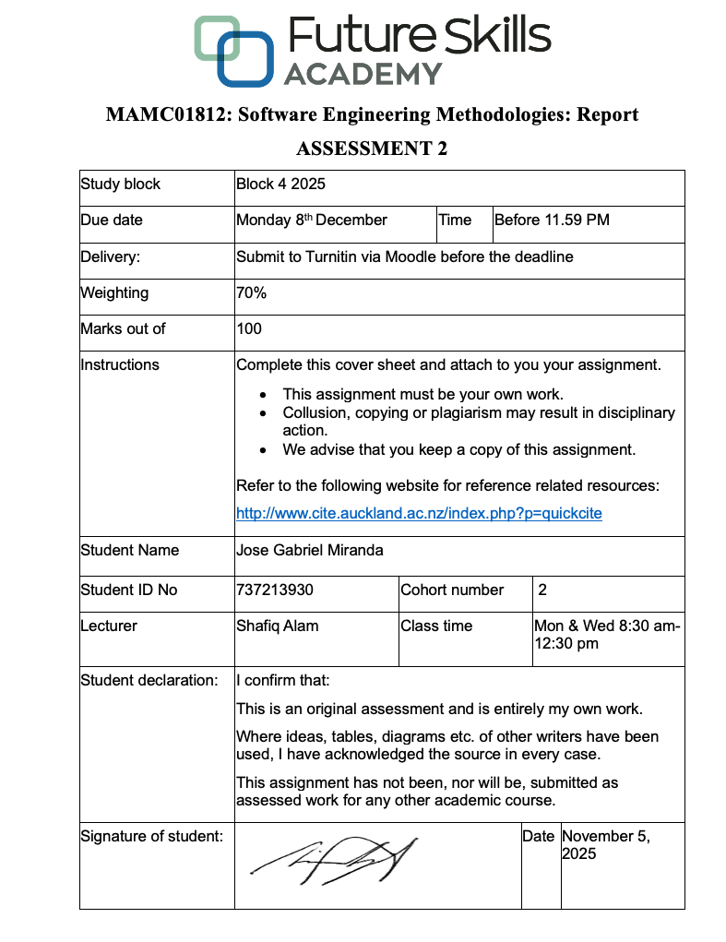

The Application of DevSecOps for Building a Secure Trading Platform

- Introduction
Agile methodology represents a fundamental shift in software development, that focuses on flexibility, teamwork and quick iteration rather than rigid, plan-driven processes. It helps teams respond to changes quickly, deliver working software regularly and maintain strong communication between developers and stakeholders throughout the development process. Agile methodologies are important because they allow software teams to handle changing requirements and deliver value to users faster. Moreover, it also improves teamwork and product quality by encouraging continuous feedback and regular updates throughout the development process.
This report will focus on Sharesies, a New Zealand based investment platform headquartered in Wellington that gives users access to companies and exchange-traded funds (ETFs) across New Zealand, Australia and the United States. The platform is known for making investing simple and accessible through a user-friendly interface and low minimum investment options. This project aims to explore the development and improvement of a trading platform of Sharesies, focusing on speed, scalability and data security while applying Agile methodology to ensure adaptability and continuous user feedback throughout the development process.
The main objective of this report is to critically analyse the history and evolution of software engineering methodologies. It also aims to evaluate different methodologies by comparing their strengths, weaknesses and suitability for developing a trading platform like Sharesies. Finally, the report will select and apply one suitable Agile model to the project, assess its effectiveness in addressing specific challenges and provide recommendations for improvement supported by academic research and industry best practices.
This report is structured into four sections. It begins with the evolution of Agile methodologies, followed by an assessment of Scrum and DevSecOps for a trading platform. The third section applies DevSecOps to the Sharesies trading platform software project then the report concludes with the selected methodology and its business value.
- Evolution of Agile Software Development
The evolution of Agile methodology emerged as a response to the limits of plan-driven methodology like Waterfall, V-model and Spiral Model. During the early decades of software engineering, development processes were rigid, documentation-heavy and often slow to adapt to change, and full of bureaucracy (Krancher, 2020). Because of this, many organisations found that strictly sequential models caused delays, high costs and misalignment between business needs and technical execution, led to the search for a more adaptive approach capable of handling changes more easily and deliver results iteratively (Mirza & Datta, 2019).
Agile software development formally began with the publication of the Agile Manifesto in 2001, created by 17 software practitioners who shared similar frustrations with traditional software processes (Hohl et al., 2018). The manifesto introduced four key values: focusing on individuals and interactions over processes and tools, working software over comprehensive documentation, customer collaboration over contract negotiation and responding to change over following a plan (Hohl et al., 2018). From these values came 12 guiding principles, which provided more detailed practices for Agile teams. These ideas became the foundation of Agile software development and changed how teams approached building software.
From this philosophy, several Agile models emerged, each addressing specific needs. Scrum, become one of the most popular, organises work into short cycles called sprints, where small cross-functional teams deliver incremental features. Progress is measured through completed tasks rather than documents and meetings called daily stand-ups ensuring continuous delivery and sprint reviews and retrospective to track progress and improve collaboration (Sutherland, 2001). Teams also use tools such as burndown chart to monitor how much work remains, helping them stay on schedule and identify issues early (Sutherland, 2001). Kanban followed, which focuses on visualizing workflow and managing work-in-progress (WIP), basically minimising the tasks in WIP so the developer can focus on one task at a time (Ahmad et al., 2013). Moreover, using a board with columns representing different stages of development, so teams can easily identify bottlenecks and maintain a steady flow of tasks (Ahmad et al., 2013). Extreme programming (XP) is a software development approach that emphasises simplicity, test-driven development (TDD) and flexible roles, where one person can act as both developer and tester (Beck, 1999). Unlike requirements-driven development, XP integrates coding and testing simultaneously, creating test cases first to ensure robust coverage while avoiding unnecessary complexity (Beck, 1999). It is best suited for complex, heavily coded projects, unlike Scrum or Kanban, which suit simpler projects. Lean software development focuses on minimising waste by writing code only when needed and from a testing perspective (Poppendieck & Poppendieck, 2003). It follows a just-in-time approach, delivering features as they are required rather than proactively doing it. Waiting or doing features too early is against lean, as any delays or unnecessary waiting are considered waste and must be avoided for efficiency (Poppendieck & Poppendieck, 2003).
Over the years, Agile grew from being used by small development teams to large organisations resulting to newer models such as Scaled Agile Framework (SAFe) and DevSecOps which extended Agile to cover bigger projects and included testing, automation, security and collaboration between departments (George, 2024). These models make Agile suitable for complex industries such as financial technology where systems must be fast, secure and continuously updated. In the case of developing trading platforms, one advantage is that there are market downtimes when trading is closed, and that period can be used to apply system updates or maintenance. The platform, however, needs to handle live data updates, process trades instantly and stay compliant with financial regulations when it is running. Using agile methodology helps the team adapt quickly to new rules or user requests, push regular updates and fix issues to maintain reliability and customer satisfaction. To summarise the progression of software engineering approached discussed above, the figure below presents a visual timeline of Agile’s evolution from traditional models to modern security-integrated methodologies.
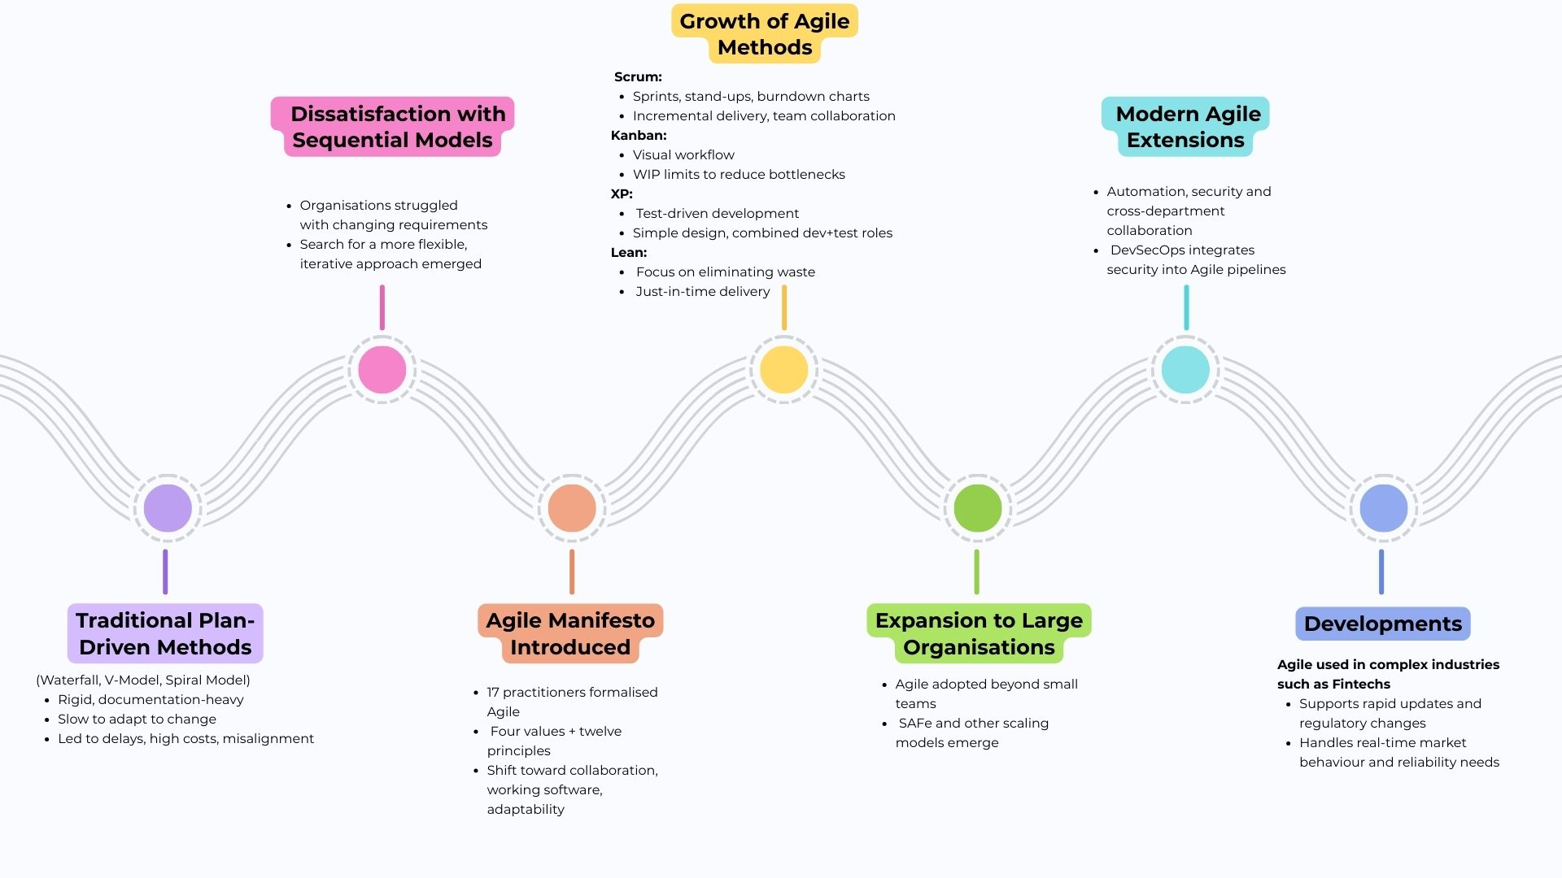
Figure 1
Evolution of Agile Software Development

- Trading Platform Software for Sharsies using Agile Methodology.
This report focuses on managing a project to develop a Trading Platform for Sharsies that focuses on building a secure and reliable system where users can trade NZ, AU and US shares in real-time. It is a complex project because it deals with live financial data, so the system must be stable even when there is high traffic or sudden surge in market activity. Moreover, security is critical since it handles users’ funds and personal data, while reliability ensures trades are executed without delays, errors or downtime during live market sessions. Additionally, the platform must be scalable to accommodate a growing user base and user-friendly for beginners. Lastly, as technology evolves, the problem should allow new features to be added and tested easily, minimising issues while keeping users engaged and satisfied.
Various agile methodologies are being used in developing trading platforms, and upon research, the most popular ones are Scrum and DevSecOps. To clearly understand the difference between the two approaches before the detailed discussion, table below provides a concise comparison of Scrum and DevSecOps.
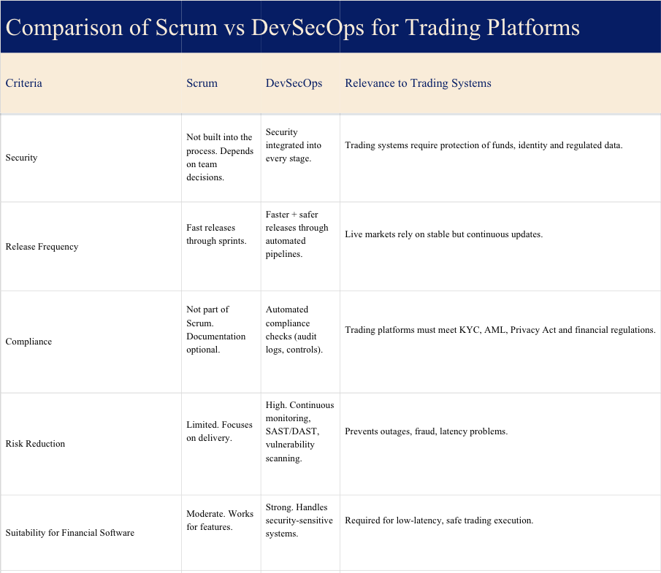
Table 1
Comparison of Scrum and DevSecOps for Trading Platforms
In the trading app project by nventive (2024), the development team used Agile practices like weekly sprints, daily stand-ups by videoconference and continuous discussions with client and team of developers, and meticulous documentation of business requirements. This shows how scrum can help manage continuous changes, feature development in a live trading environment and the ability to deliver working software. Meanwhile, DevSecOps, according to Dasanayake et al. (2025), focuses on integrating security throughout the development process using automated testing and continuous monitoring. This approach ensures that every release meets strict financial and data protection standards and regulations.
Scrum and DevSecOps are both suitable for developing a trading platform, but each plays a different role. To support the methodology selection process, a table below links key trading-system requirements with the level of support provided by Scrum and DevSecOps.
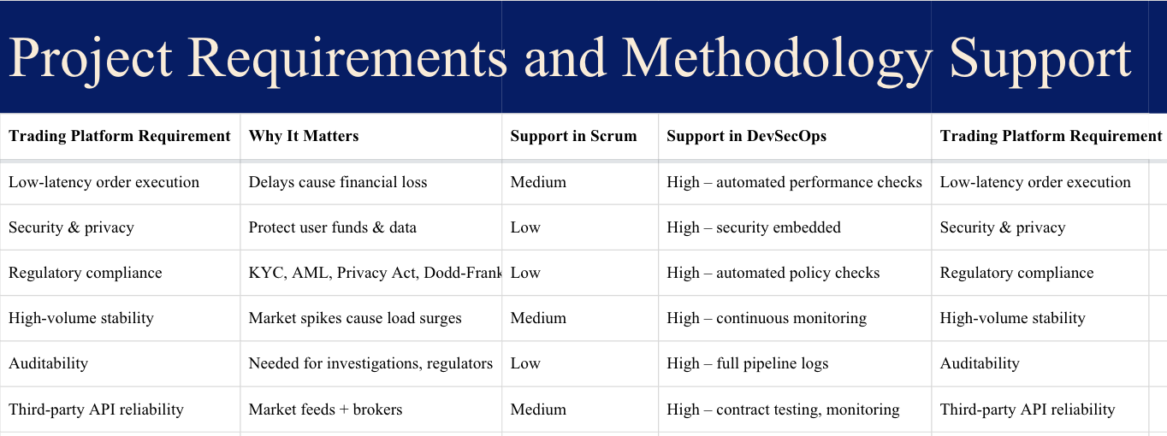
Table 2
Trading Platform Requirements and Methodology Support
Scrum’s main advantage is fast and flexible delivery. In the nventive trading app case, weekly sprints and stand-ups helped the team release updates quickly and respond to changing requirements, which is important in a system where user needs and market conditions shift often. However, scrum does not prioritise or enforce security during development. Security is only included if the team adds it themselves, which becomes risky in financial software where the system processes live financial data, user transactions and sensitive information from the start. Hence, DevSecOps, becomes more suitable because it directly addresses the main weakness found in trading systems, speed without security. According to Dasanayake et al. (2025), financial trading software often “prioritises speed over security” and defers security to later stages, exposing platforms to threats like ransomware, data exfiltration and account hacking. DevSecOps fixes this by shifting security left and embedding automated security checks, secure coding and continuous testing into the development. For a project building a trading platform with many moving parts such as real-time price data, algorithmic trading logic or external APIs, DevSecOps is more suitable because it protects the system without slowing delivery.
Scrum and DevSecOps clearly address different risks in software development especially in financial systems. According to Munteanu & Dragos (2021), scrum strengths are to increase efficiency, transparency and stakeholder satisfaction in financial software projects, mainly by helping teams adapt quickly and deliver features faster. However, weaknesses such as low predictability, dependency on constant customer involvement and lighter documentation presents serious issues in the trading context because in a regulated environment such as the financial markets, systems must provide traceability, auditability and control especially due to the risks of money laundering and financial misconduct. Moreover, scrum does not directly address cyber risk, secure coding or compliance. Teams can work in sprints, deliver fast and still miss critical security requirements.
Meanwhile, Dasanayake et al. (2025) approach DevSecOps from the security perspective, showing that financial trading platforms often prioritise speed over security, which leads to vulnerabilities and regulatory exposure. Dasanayake et al.'s (2025) DevSecOps model fixes this by embedding security into every part of the project, improving collaboration between development, security and operations and using automation, secure coding and continuous monitoring to increase quality. This makes DevSecOps not just “Agile with security”, but a development approach built around the actual risks of trading systems, such as protecting data, meeting regulations and handling evolving cyber threats without slowing down delivery. Industry practice also supports this wherein modern trading platforms such as Citadel and Two Sigma rely heavily on DevOps principles to maintain security, auditability and low-latency execution (Clarke, 2024).
- Application of DevSecOps for Trading Platform Software
As requirements and risks evolve, the use of methodology must evolve as well. For this project the most appropriate methodology is DevSecOps because a trading platform must meet strict security, compliance, reliability and safety (Reszka, 2024). It handles live financial data, user transactions and sensitive personal information, so the project requires continuous security, strong governance and automated controls. Regulations such as GDPR, the NZ Privacy Act 2020 and Dodd-Frank (US), together with industry practices from firms like Citadel and Two Sigma, reinforce the need for a security-driven approach from the start (Clarke, 2024). To provide a clearer overview of how DevSecOps functions in this project, figure below illustrates the end-to-end process from user-story creation through deployment and post-release monitoring.
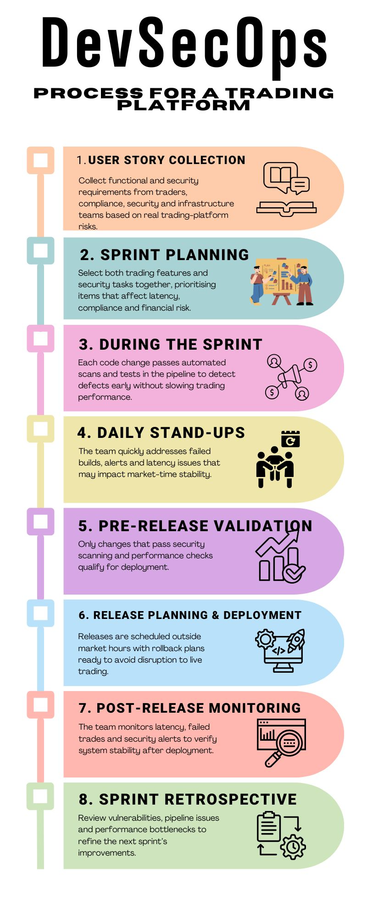
Figure 2
DevSecOps Process for a Trading Platform Project
Although DevSecOps is the core methodology for this project, scrum ceremonies such as sprint planning, daily stand-ups and retrospectives are still used to organise teamwork and manage iterative delivery. This aligns with Orosz et al. (2022) who observed DevSecOps teams routinely apply Agile and Scrum practices within DevSecOps pipelines.
User story collection will focus on the needs of business users, security teams and technical stakeholders since trading platforms handle live financial data and sensitive personal information (Linskens, 2025). Stories will be gathered from several groups such as the traders, they will provide the core functional needs such as order placement, execution speed and market-data display. Compliance and security teams will define the required controls such as KYC checks, MFA, audit logs and data protection rules. Market-data and infrastructure teams will contribute stories relating to latency, feed reliability and system performance. The development, QA and DevSecOps teams will supply pipeline stories such as vulnerability checks and automated testing. Stories will then be collected through stakeholder interviews, workshops, regulatory analysis and reviews of previous incidents in trading systems. DevSecOps will also generate stories from pipeline results and monitoring logs. For example, user stories such as “As a trader, I need my market orders to execute in < 50ms so I can react to price changes” and “As a security engineer, I need MFA in the login process to accounts stay protected”. Once collected, all stories will be added to a continuously updated backlog and prioritised based on risk, regulatory timelines and business value.
When sprint planning starts, the team selects both the trading features and the security work that must be completed. This includes order-execution improvements, market-data updates, MFA work, audit-log changes and any vulnerabilities identified in the pipeline. In a trading platform, these non-functional requirements are treated as first-class backlog items because they affect latency, compliance and financial risk (Behutiye et al., 2017). The team also recognises that performance and security tasks can be harder to estimate, so sprint planning includes dependency checks and capacity discussions to avoid over-committing. During the sprint, everyone shares responsibility for keeping the system fast and secure (Dasanayake et al., 2025). Each code change is checked by the Continuous Improvement/Continuous Development pipeline, which runs static code scans, automated tests and performance checks (Gami et al., 2025). These are critical because even small defect can slow down order execution or financial risks. The daily meeting focuses on progress and anything slowing the pipeline, such as failed builds, new security alerts, latency issues or test failures. By the end of the sprint, the team reviews which items are ready for release based on objective pipeline results, and only changes that pass all functional, security and performance checks are approved for deployment (Aamir & Khan, 2017).
For this project, releases are planned carefully to make sure the system stays secure, fast and stable. Release planning looks beyond a single sprint and brings together the key features, security work and technical updates that need to go live over the next few cycles (Sinan et al., 2025). The release can be a major release that introduces bigger changes to trading or market-data features, a minor release with performance improvements or enhancements or a patch release focused on urgent security fixes or bugs (Dasanayake et al., 2025). Before anything is deployed all changes must pass SAST, which scans the source code for security issues before it runs and DAST, which tests the running application for vulnerabilities along with performance checks to confirm order-execution speed and market data handling remain stable (Adeyinka, 2024). Releases are scheduled outside market hours, and version control is prepared in case issues appear. After deployment, the team monitors latency, failed trades and security alerts to guide the next release.
At the end of each sprint, the team holds a retrospective to look at how the work was delivered and to identify improvements for the next sprint. For a trading platform, topics on areas that affect security, performance and stability is critical. The team reviews vulnerabilities caught by SAST or DAST, any issues that reached staging, slow pipeline steps and any problems that could impact order execution or market-data flow (Adeyinka, 2024). They also look at collaboration between Dev, Sec and Ops to see if issues were handled quickly. From this, the team agrees on practical changes, such as refining scan rules, improving alert handling, or tightening checks around trading-related APIs.
To track work and the days of work remaining, the burndown chart will be important for this project. It will show the team’s progress across both trading features and security-related tasks, including SAST and DAST findings, authentication updates and any pipeline changes. This helps the team see early if something is slowing progress. Also, the team monitors the DORA Metrics which is the most critical metrics in a DevSecOps environment, which indicate how fast and how safely yet securely changes move through the delivery pipeline (Ramaswamy, 2020).
As a trading software project, security is extremely important because the system handles confidential financial data and real user funds (Dasanayake et al., 2025). The platform must stay safe, reliable and risk-free, especially when the market is open and large volumes of trades are being processed. Companies like Sharsies earn revenue from customers trading with huge amounts of money, so any outage or security issue directly affects income and user trust. DevSecOps ensures stable performance and strong security, which results in a continuous development of the software (Abiona et al., 2024). Moreover, it may result to higher customer lifetime value which refers to the total revenue a customer generates over their entire relationship with the platform, so improving reliability encourages users to stay long, trade more frequently and deposit larger funds.
- Conclusion
In summary, DevSecOps is the most suitable methodology for developing a secure and reliable trading platform, particularly for projects that involve financial transactions, confidential data and strict regulatory requirements. It provides continuous security, strong governance and safe delivery practices that match the demands of real-time trading systems. By using DevSecOps, FinTech organisations can scale safely, maintain customer trust and strengthen long-term business value.

- References

Aamir, M., & Khan, M. N. A. (2017). Incorporating quality control activities in scrum in relation to the concept of test backlog. Sādhanā, 42(7), 1051–1061. https://doi.org/10.1007/s12046-017-0688-7
Abiona, O. O., Oluwatayo Jacob Oladapo, Oluwole Temidayo Modupe, Oyekunle Claudius Oyeniran, Adebunmi Okechukwu Adewusi, & Abiola Moshood Komolafe. (2024). The emergence and importance of DevSecOps: Integrating and reviewing security practices within the DevOps pipeline. World Journal of Advanced Engineering Technology and Sciences, 11(2), 127–133. https://doi.org/10.30574/wjaets.2024.11.2.0093
Adeyinka, A. (2024). Application Security: The Perspective of a Program Manager. International Journal of Innovative Science and Research Technology (IJISRT), 2938–2941. https://doi.org/10.38124/ijisrt/IJISRT24MAY2349
Ahmad, M. O., Markkula, J., & Oivo, M. (2013). Kanban in software development: A systematic literature review. 2013 39th Euromicro Conference on Software Engineering and Advanced Applications, 9–16. https://doi.org/10.1109/SEAA.2013.28
Beck, K. (2000). Extreme programming explained: Embrace change. Addison-Wesley Professional.
Behutiye, W., Karhapää, P., Costal, D., Oivo, M., & Franch, X. (2017). Non-functional Requirements Documentation in Agile Software Development: Challenges and Solution Proposal. In M. Felderer, D. Méndez Fernández, B. Turhan, M. Kalinowski, F. Sarro, & D. Winkler (Eds.), Product-Focused Software Process Improvement (Vol. 10611, pp. 515–522). Springer International Publishing. https://doi.org/10.1007/978-3-319-69926-4_41
Dasanayake, S. D. L. V., Senanayake, J., & Wijayanayake, W. M. J. I. (2025). DevSecOps Implementation for Continuous Security in Financial Trading Software Application Development. 2025 5th International Conference on Advanced Research in Computing (ICARC), 1–6. https://doi.org/10.1109/ICARC64760.2025.10963292
Gami, S. J., Katru, C. R., & Shah, K. N. (2025). Enhancing Software Reliability: The Role of Automated Continuous Integration and Continuous Delivery. International Journal of Computer Applications, 187.
George, Dr. A. S. G. (2024). Finance 4.0: The Transformation of Financial Services in the Digital Age. https://doi.org/10.5281/ZENODO.11666694
Harrison Clarke. (2024, April 1). How DevOps/SRE talent transforms financial trading systems. https://www.harrisonclarke.com/blog/how-devops/sre-talent-transforms-financial-trading-systems#:~:text=One%20of%20the%20key%20benefits,trails%2C%20and%20secure%20development%20practices
Hohl, P., Klünder, J., Van Bennekum, A., Lockard, R., Gifford, J., Münch, J., Stupperich, M., & Schneider, K. (2018). Back to the future: Origins and directions of the “Agile Manifesto” – views of the originators. Journal of Software Engineering Research and Development, 6(1), 15. https://doi.org/10.1186/s40411-018-0059-z
Krancher, O. (2020). Agile Software Development Practices and Success in Outsourced Projects: The Moderating Role of Requirements Risk. In V. Stray, R. Hoda, M. Paasivaara, & P. Kruchten (Eds.), Agile Processes in Software Engineering and Extreme Programming (Vol. 383, pp. 56–72). Springer International Publishing. https://doi.org/10.1007/978-3-030-49392-9_4
Linskens, A. (2025, February 26). Building a security-minded development team: DevSecOps tools and SDLC best practices. Sonatype. https://www.sonatype.com/blog/building-a-security-minded-development-team-devsecops-tools-and-sdlc-best-practices
Mirza, M. S., & Datta, S. (2019). Strengths and Weakness of Traditional and Agile Processes—A Systematic Review. Journal of Software, 14(5), 209–219. https://doi.org/10.17706/jsw.14.5.209-219
Munteanu, V. P., & Dragos, P. (2021). The Case for Agile Methodologies against Traditional Ones in Financial Software Projects. European Journal of Business and Management Research, 6(1), 134–141. https://doi.org/10.24018/ejbmr.2021.6.1.741
Orosz, M., Nguyen, C., Marshall, C., Powell, J., Elgersma, K., Michalak, S., & Ouyang, M. (2022). Introducing Agile/DevSecOps into the space acquisition environment. Systems Engineering & Modeling. https://apps.dtic.mil/sti/trecms/pdf/AD1167447.pdf
Poppendieck, M., & Poppendieck, T. (2003). Lean software development: An agile toolkit. Addison-Wesley.
Ramaswamy, Y. (2020). DevOps Metrics that Matter: A Data-Driven Approach toPerformance Measurement and Team Productivity. International Journal of Communication Networks and Information Security.
Reszka, P. (2024, March 18). DevOps solution for a trading system on GCP private cloud. Inigra Software House. https://inigra.eu/devops-trading-system-gcp/
Sinan, M., Shahin, M., & Gondal, I. (2025). Integrating Security Controls in DevSecOps: Challenges, Solutions, and Future Research Directions. Journal of Software: Evolution and Process, 37(6), e70029. https://doi.org/10.1002/smr.70029
Sutherland, D. J. (2001). Inventing and Reinventing SCRUM in Five Companies. Cutter IT Journal.

